Citizen AI – Intelligent Citizen Engagement Platform

Abstract
The project Citizen AI – Intelligent Citizen Engagement Platform aims to bridge the gap between citizens and governing authorities through an AI-driven, user-friendly chatbot system. This platform enables seamless communication, allowing users to raise queries, report local issues, and provide valuable feedback in a conversational manner. By leveraging Generative – AI, the chatbot interprets user inputs and provides instant, context-aware responses. Additionally, the platform includes modules such as feedback collection, issue reporting, and an admin dashboard to ensure smooth management and transparency. Designed using Python for the backend and HTML, inline CSS, and JavaScript for the frontend, the system enhances public engagement and promotes efficient civic service delivery.

Introduction
In recent years, the integration of Artificial Intelligence into public services has transformed how citizens interact with government systems. Traditional methods of communication, such as phone calls or manual grievance redressal, are often slow and inefficient. To overcome these limitations, the Citizen AI platform has been developed to provide an intelligent, interactive, and responsive interface between citizens and civic authorities.
The main objective of this project is to create a chatbot-based platform that assists users in obtaining information, reporting issues, and submitting feedback without human intervention. The system aims to simplify user interactions while ensuring that every query or complaint is recorded and addressed effectively. With its intuitive design and powerful backend, Citizen AI contributes toward building smarter cities and more responsive administrations.

Proposed System
The Citizen AI platform proposes a comprehensive web-based system powered by Generative-AI to enable intelligent communication between citizens and authorities. The chatbot acts as the central component of the system, capable of understanding user intents and responding to queries promptly.
The proposed system includes the following modules:
- Chatbot Interaction – A Gen AI-powered chatbot designed to understand and respond to user queries using IBM Granite model. It provides answers related to services, procedures, and general inquiries.
- Feedback Collection – A module that allows users to share their experience and satisfaction levels. This feedback is stored and analysed for future service improvements.
- Issue Reporting – A user-friendly interface for citizens to report problems such as infrastructure damage, sanitation issues, or service delays. Each report is logged and accessible through the admin panel.
- Admin Dashboard – A management panel for administrators to monitor user sentimental feedbacks, track reported issues, and ensure timely responses.
- About Page – Provides users with details about the platform, its purpose, and development background.
- Service Page – Lists all available services and functionalities the platform offers to the users.
- Login Page – Ensures secure user authentication for both citizens and administrators, protecting data integrity and personalized interactions.
- Index / Starting Page – The homepage offering easy navigation and a clean user interface, allowing users to access the chatbot, services, and information effortlessly.
The system aims to deliver real-time, and human-like responses to enhance citizen satisfaction and improve administrative efficiency.

System Requirements and Tools & Technologies Used
- Hardware Requirements
  - Processor: Intel i3 or above
  - RAM: Minimum 4 GB (8 GB recommended)
  - Hard Disk: Minimum 250 GB
  - Operating System: Windows / Linux / macOS

- Software Requirements
  - Frontend Technologies: HTML, CSS, JavaScript
  - Backend Language: Python
  - Framework : Flask
  - Libraries:
    - Flask libraries (render_template, request, redirect, url_for, session, jsonify),
    - Transformers libraries (AutoModelForCausalLM, AutoTokenizer, BitsAndBytesConfig, pipeline),
    - DateTime libraries (datetime, timedelta),
    - Torch ,
    - FuncTools library (wraps).
  - Editor/IDE: Visual Studio Code
  - Browser: Google Chrome / Brave / Microsoft Edge

- Tools and Technologies Used
  - Python: Used for backend development, chatbot logic, and data handling.
  - HTML, CSS, JavaScript: Provide structure, design, and interactivity for the user interface.
  - Flask: Simplifies server-side operations and communication between front-end and database.
  - VS Code: Integrated development environment for coding, debugging, and UI design.
This combination of technologies ensures reliability, scalability, and seamless interaction between the system’s components.

System Design / Architecture
The architecture of Citizen AI follows a client–server model integrating both front-end and back-end components:
- Frontend: Designed using HTML, CSS, and JavaScript, providing an interactive and responsive web interface where users can chat, report issues, or give feedback.
- Backend: Developed in Python, which handles chatbot processing, query handling, and database management. The backend processes user messages, retrieves or stores information, and sends appropriate responses to the frontend.
- Admin Panel/Dashboard: A protected interface for authorized personnel to view analytics, monitor performance, and manage citizen interactions efficiently.
This modular design ensures scalability, maintainability, and secure data handling while delivering a seamless user experience.

Outputs / Screenshots
The following screenshots (to be inserted) illustrate the working of the Citizen AI platform:
Home / Index Page: Displays an overview of services and provides access to the chatbot.
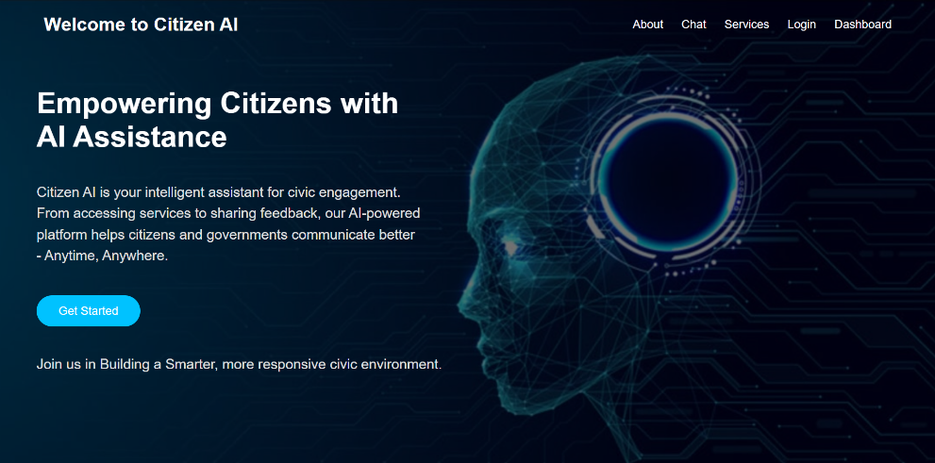

Login Page: Allows users and admins to securely access the platform.
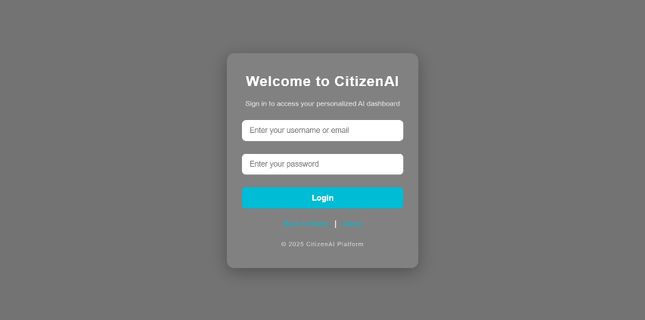

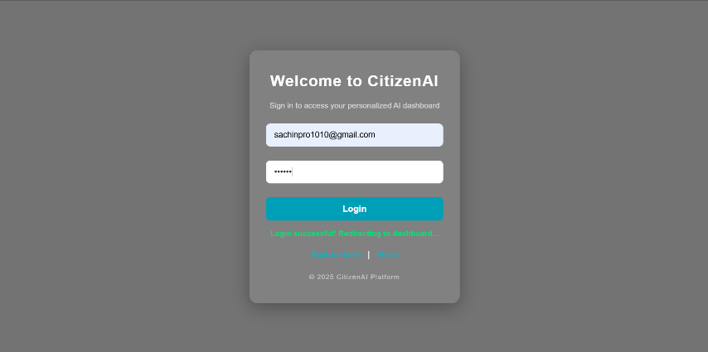

About Page: Provides users with details about the platform, its purpose, and development background.
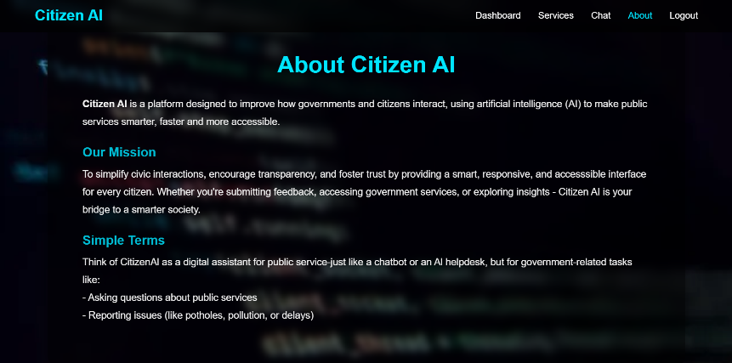

Service Page: Lists all available services and functionalities the platform offers to the users.
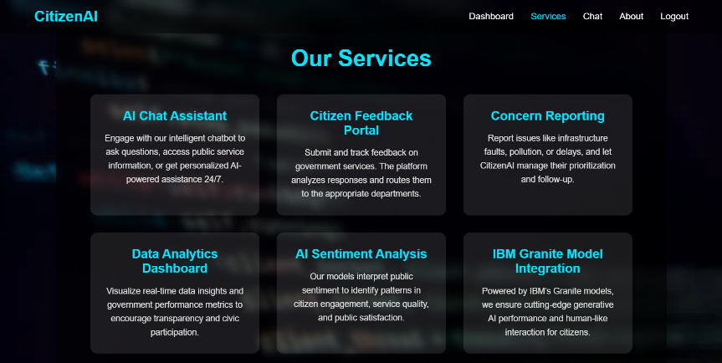

Chatbot Interface: The AI chatbot responding to user queries in real-time.
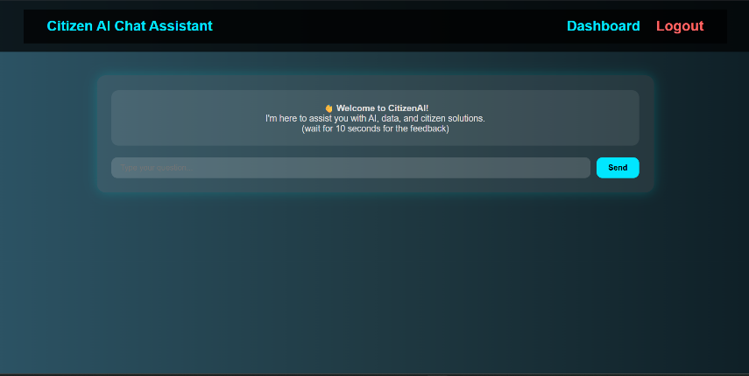

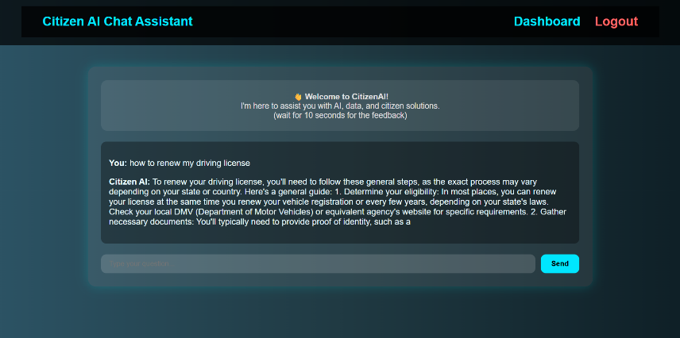

Feedback Page: Section where users provide feedback on services.
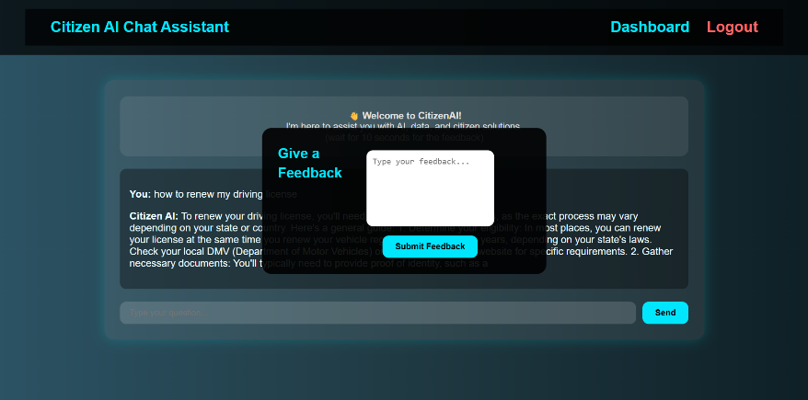

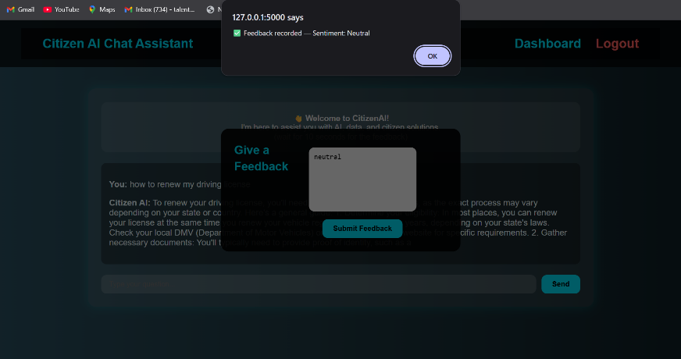

Issue Reporting Page: Interface for users to log civic issues.
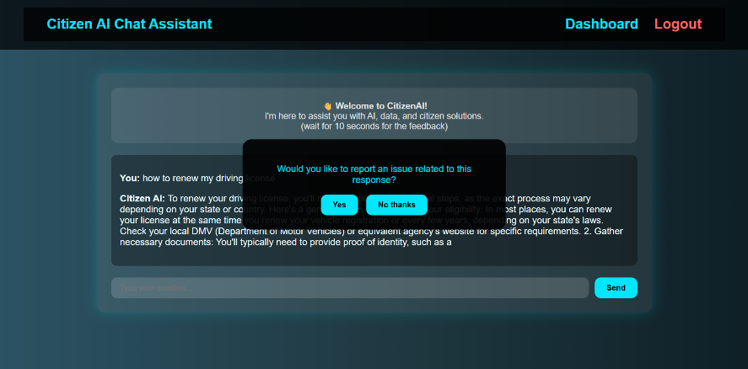

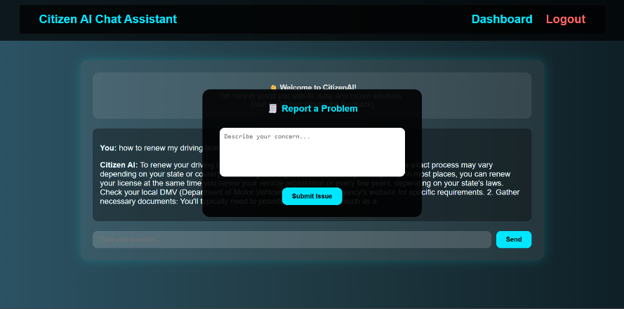

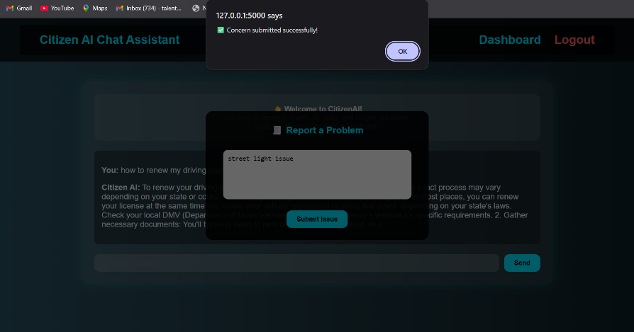

Admin Dashboard: Overview of reported issues, chatbot logs, and user analytics.
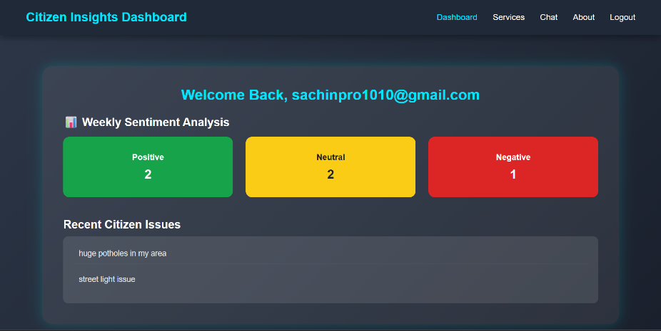

Conclusion
The Citizen AI – Intelligent Citizen Engagement Platform successfully demonstrates how AI can revolutionize citizen interaction with public services. By automating query handling, feedback management, and issue reporting, the platform reduces response times and enhances transparency. It simplifies communication between citizens and governing authorities, fostering a more engaged and satisfied community.

Future Scope
Future Enhancements may include:
- Integration with voice-based assistants for hands-free interaction.
- Multilingual chatbot support to cater to diverse populations.
- Real-time notifications and status updates for reported issues.
- AI-based analytics to predict common citizen concerns and improve service delivery.
- Through continued development, Citizen AI can evolve into a powerful digital governance tool contributing to the vision of smart and connected cities.

